**A REPORT SUBMITTED AS A PART OF EXPERENTIAL LEARNING ON DATABASE ENGINEERING(CSE23306)**

TOPIC: HOSTEL MANAGEMENT SYSTEM



**Submitted By:**

**Guided By: Regd. No Name**

**Dr. Prasant Kumar Dash 2201020944 Akshat Sharma**

**Asst. Prof., Dept. of CSE 2201020640 Shyam Prakash**

**Dept. of CSE, CGU, Odisha 2201020880 Rakesh Kumar**

**Department of Computer Science & Engineering**

**C.V. Raman Global University, Bhubaneswar, Odisha**

**752054**

**Table of Contents**

1. **Problem Statement 1**
2. **Introduction 2**
   1. **Background 2**
   2. **Challenges 3**
3. **Proposed Solution 4**
   1. **Relations 4**
   2. **Relational Schema 5**
   3. **Schema Diagram 6**
   4. **ER Diagram 7**
4. **Result & Analysis 10**
   1. **Table Creation 11**
   2. **Constraint 12**
   3. **Table Insertion 13**
   4. **Table Updation 14**
   5. **Lists of Queries 15**
5. **Conclusion 15**

**Problem statement**

We are group 8 from DBE CASE STUDY GROUPING FORMAT, hereby declare that we have done a case study on the topic of "HOSTEL MANAGEMANT SYSTEM". The purpose of this case study is to understand the management system adopted by CV Raman Global University and its effectiveness in achieving the objectives of the university.

fI confirm that all information and data collected during the course of this case study will be used solely for academic purposes and will be kept confidential.

Furthermore, I acknowledge that all sources of information used in this study will be appropriately cited and referenced, and I will not engage in any form of plagiarism.

I understand that this declaration is a formal statement of my commitment to academic integrity and ethical research practices.

**Introduction**

**Background :**

Hostel management systems are important for running places where people live temporarily, like dormitories for students or accommodation for travelers. These systems help make sure everything in the hostel runs smoothly.

In the past, managing hostels meant lots of paperwork and manual tasks. But now, technology has made things easier. New systems use computer programs to handle bookings, room assignments, and other tasks more efficiently.

Even with these improvements, there are still challenges. These include things like handling lots of people, meeting their needs, and following rules and regulations.

In this document, we'll talk about these challenges and suggest ways to solve them, so hostels can run better and make everyone happy.

**Key point:**

* Hostel management historically relied on manual processes such as paper records and in-person communication.
* Tasks included managing bookings, room assignments, and resident information.
* The rise of technology has revolutionized hostel management systems.
* Modern systems automate tasks, offering features like online booking platforms and integrated communication tools.
* Benefits include increased efficiency, reduced errors, and improved resident satisfaction.

**Challenges :**

1. **Accommodation Allocation:**
   * Managing room assignments efficiently, especially during peak admission periods, to ensure fair and transparent allocation processes.
2. **Resident Welfare:**
   * Ensuring the safety, well-being, and comfort of residents through adequate amenities, health, and hygiene standards.
3. **Community Building:**
   * Fostering a sense of community among residents from diverse backgrounds, encouraging social interaction, and addressing conflicts or disputes.
4. **Security Measures:**
   * Implementing and maintaining robust security systems within the hostel premises to prevent theft, unauthorized access, or intrusions.
5. **Infrastructure Maintenance:**
   * Regular upkeep and maintenance of hostel infrastructure, including buildings, utilities, and common areas, to ensure resident safety and comfort.
6. **Regulatory Compliance:**
   * Adhering to college and government regulations regarding hostel operations, safety standards, hygiene protocols, and student welfare to avoid penalties or legal issues.

Addressing these challenges effectively is essential for ensuring the smooth functioning of college hostels and providing a conducive living environment for students.

**Proposed Solution**

**Relations:**

There are three type of relations to case study was followed:

1. Student-Hostel Room Allocation
2. Inventory management
3. Staff Allocation and Duties

* **Student-hostel room allocation**

One crucial aspect of hostel management systems is the allocation of hostel rooms to students. This process involves tracking available rooms, assigning rooms to students based on their preferences and eligibility, and updating the database accordingly.

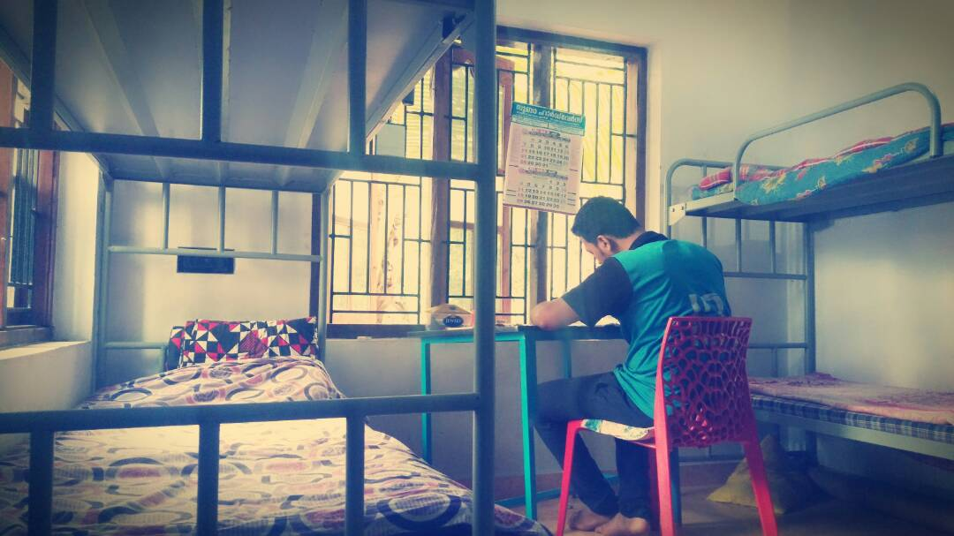

* **Inventory Management**

Inventory management is another critical aspect of hostel management systems. It involves keeping track of various items such as furniture, bedding, kitchen appliances, etc., within the hostel premises.

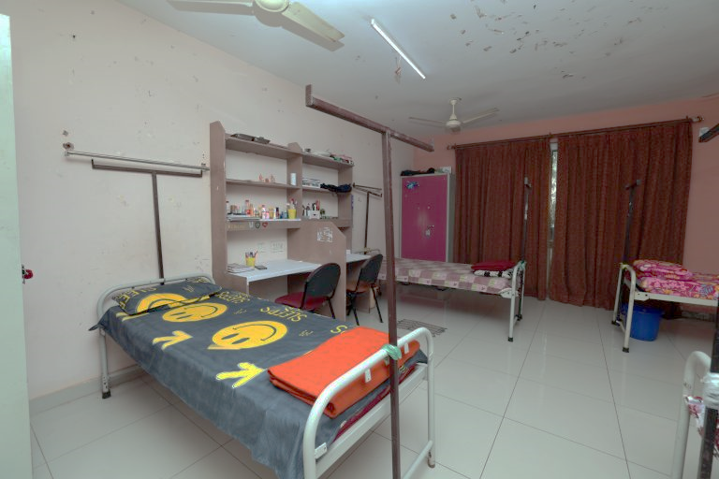

* **Staff Allocation and Duties**

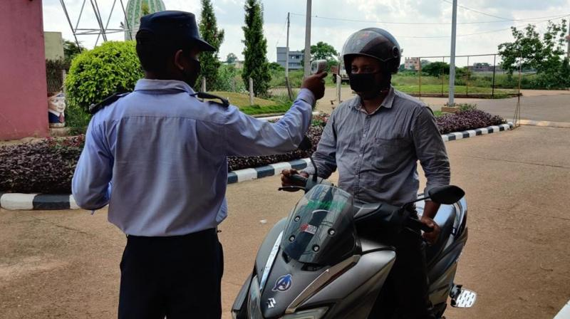Staff allocation and duties management involves assigning roles and responsibilities to hostel staff members, such as wardens, maintenance personnel, administrative staff, etc. It includes tracking staff availability, duties assigned, and any changes in responsibilities**.**

**Relational Schema**

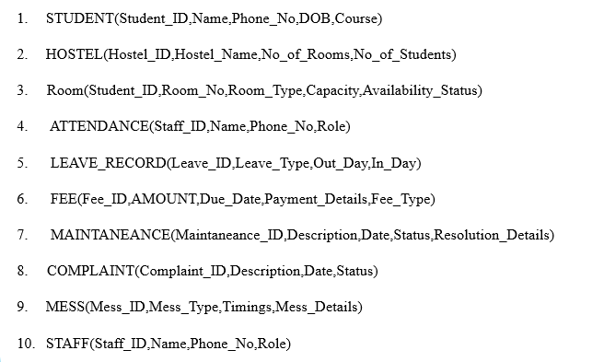

**Schema Diagram**

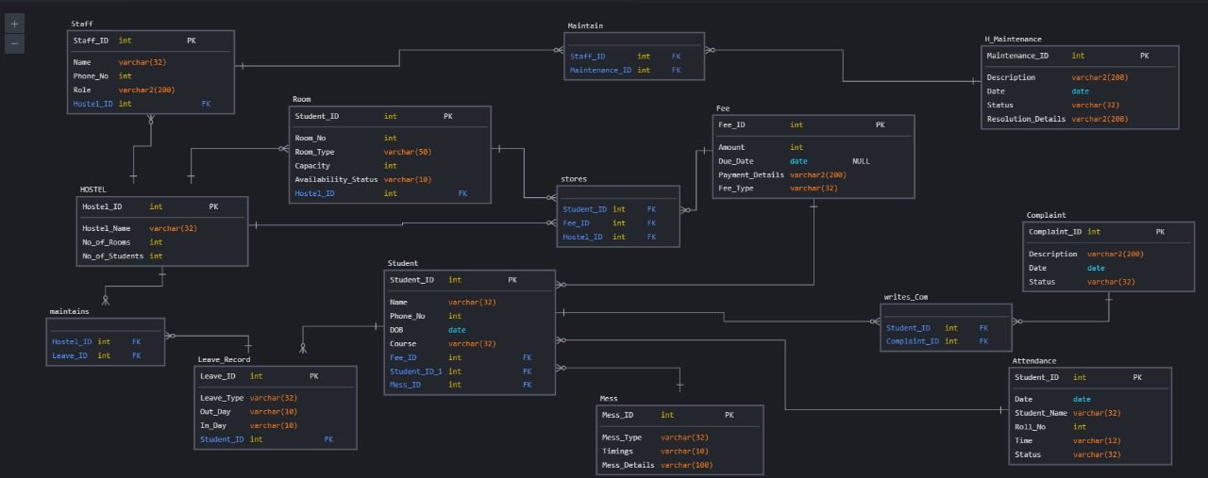In the hostel management system schema diagram, several key entities are represented, each playing a crucial role in facilitating the efficient management of hostel accommodations. The "Hostel" table serves as a repository for essential information regarding the various hostels managed within the system. It includes attributes such as the unique hostel ID, name, address, and the total number of rooms available in each hostel.

Overall, the schema diagram provides a structured representation of the hostel management system's database, enabling administrators to effectively organize, track, and manage hostel accommodations and student allocations.

**Top of Form**

**ER Diagram**

In the Entity-Relationship (ER) diagram for a hostel management system, various entities and their relationships are depicted to illustrate the structure and interactions within the system. The ER diagram typically includes entities such as "Hostel," "Room," "Student," and "Attendance," each representing a distinct aspect of hostel management.

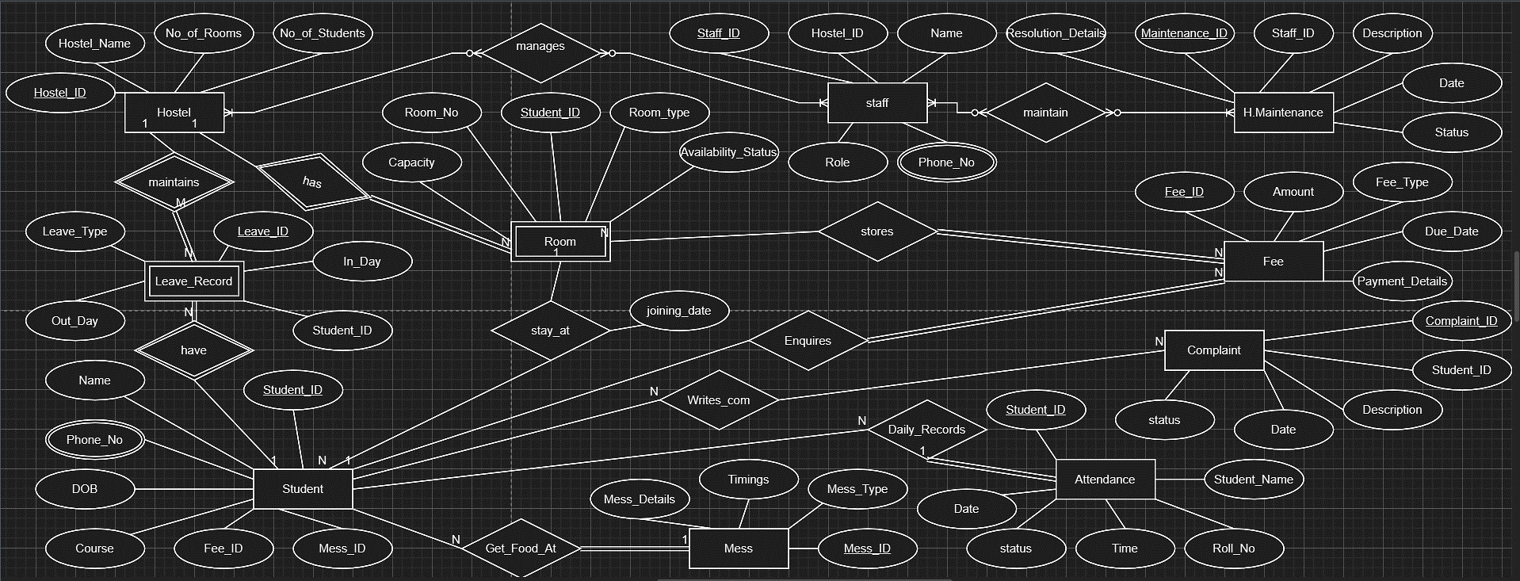

"In the ER diagram, the entities are connected through relationships. For example, the 'Room' entity is linked to the 'Hostel' entity through a relationship that indicates each room belongs to a specific hostel. Similarly, the 'Student' entity is connected to the 'Room' entity through a relationship indicating that each student resides in a particular room. Additionally, the 'Leave record' entity serves as a bridge between 'Hostel' and 'Student,' representing the assignment of rooms to students. These relationships help us understand how information flows between different parts of the hostel management system, ensuring efficient allocation of accommodations to students."

**Top of Form**

**Result & Analysis**

**Table Creation:**

CREATE TABLE hostel_info.STUDENT (

    Student_ID INT *PRIMARY KEY*,

    Name VARCHAR(32) NOT NULL,

    Phone_No BEGININT,

    DOB DATE,

    Course VARCHAR(32)

);

CREATE TABLE hostel_info.HOSTEL (

    Hostel_ID VARCHAR(10) *PRIMARY KEY*,

    Hostel_Name VARCHAR(32) NOT NULL,

    No_of_Rooms INT,

    No_of_Students INT

);

CREATE TABLE hostel_info.ROOM (

    Student_ID INT,

    Room_No INT *PRIMARY KEY*,

    Room_Type VARCHAR(50),

    Capacity INT,

    Availability_Status VARCHAR(10),

*FOREIGN KEY* (Student_ID) *REFERENCES* STUDENT(Student_ID) *ON DELETE CASCADE* ON UPDATE CASCADE

);

CREATE TABLE hostel_info.ATTENDANCE (

    Student_ID INT,

    Date DATE,

    Student_Name VARCHAR(32),

    Roll_No INT,

    Time VARCHAR(12),

    Status VARCHAR(32),

*PRIMARY KEY* (Student_ID, Date),

*FOREIGN KEY* (Student_ID) *REFERENCES* STUDENT(Student_ID) *ON DELETE CASCADE* ON UPDATE CASCADE

);

CREATE TABLE hostel_info.STAFF (

    Staff_ID VARCHAR(10) *PRIMARY KEY*,

    Name VARCHAR(32) NOT NULL,

    Phone_No BEGININT,

    Role VARCHAR(200)

);

CREATE TABLE hostel_info.LEAVE_RECORD (

    Leave_ID VARCHAR(10) *PRIMARY KEY*,

    Leave_Type VARCHAR(32),

    Out_Day DATE,

    In_Day DATE

);

CREATE TABLE hostel_info.FEE (

    Fee_ID VARCHAR(10) *PRIMARY KEY*,

    AMOUNT INT,

    Due_Date DATE,

    Payment_Details VARCHAR(200),

    Fee_Type VARCHAR(32)

);

CREATE TABLE hostel_info.H_MAINTENANCE (

    Maintenance_ID VARCHAR(10) *PRIMARY KEY*,

    Description VARCHAR(200),

    Date DATE,

    Status VARCHAR(32),

    Resolution_Details VARCHAR(32)

);

CREATE TABLE hostel_info.COMPLAINT (

    Complaint_ID VARCHAR(10) *PRIMARY KEY*,

    Description VARCHAR(200),

    Date DATE,

    Status VARCHAR(32)

);

CREATE TABLE hostel_info.Mess (

    Mess_ID VARCHAR(10) *PRIMARY KEY*,

    Mess_Type VARCHAR(32),

    Timings VARCHAR(32),

    Mess_Details VARCHAR(32)

);

**Constraint :**

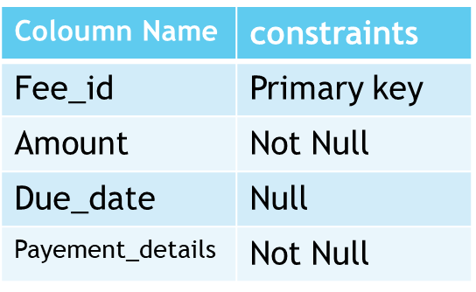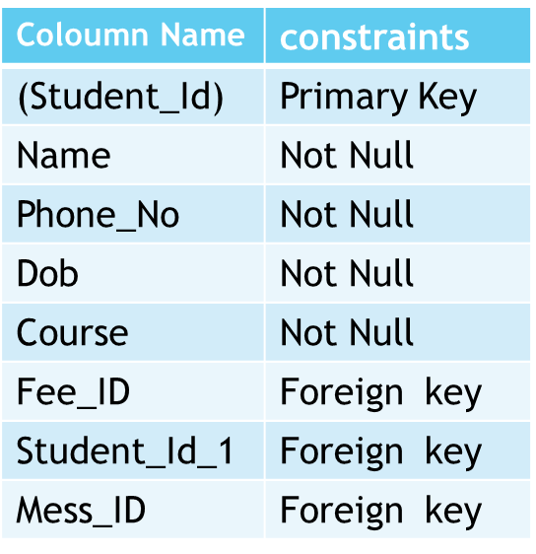**Attendance Fee**

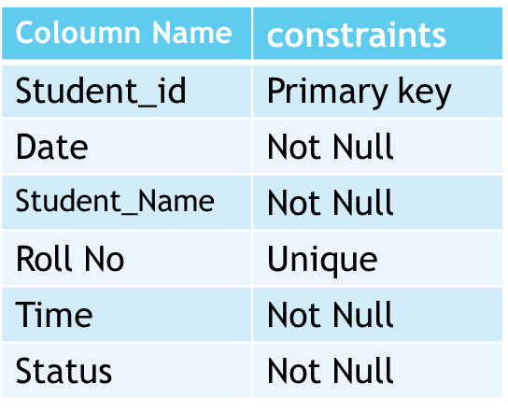**S Student**

**s**

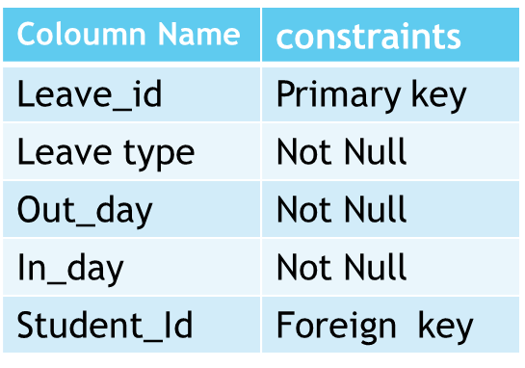**leave record mess**

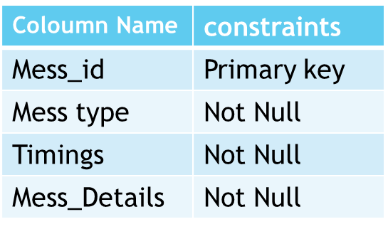

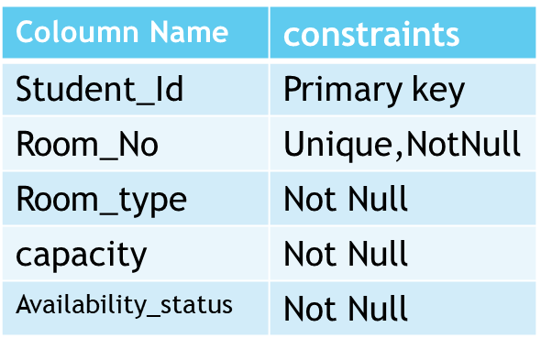**Room h_maintenance**

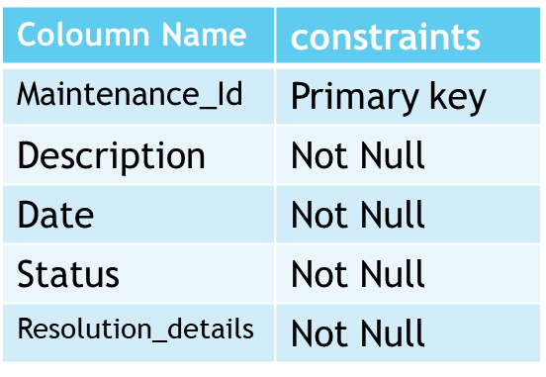

**Hostel**

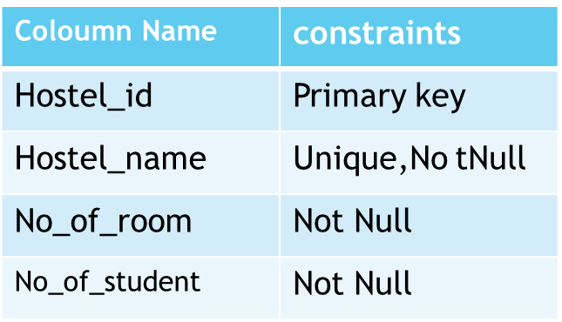

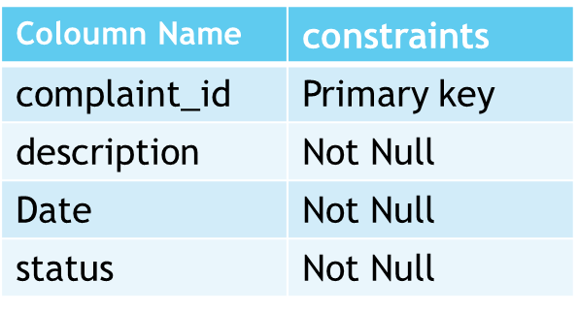**complant**

**staff**

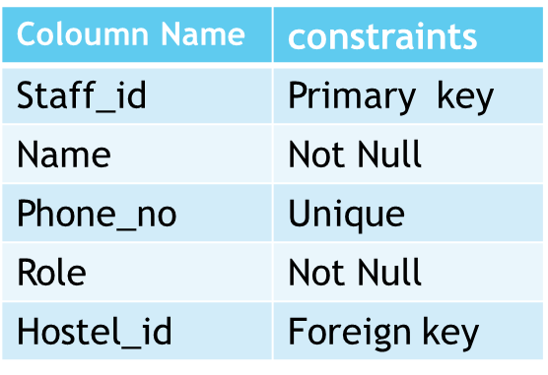

**Table insertion:**

**STAFF-:**

INSERT INTO hostel_info.staff (Staff_ID, Name, Phone_No, Role)

VALUES

    ('S101', 'Priya Gupta', 9876543220, 'Professor'),

    ('S102', 'Anil Sharma', 9876543221, 'Librarian'),

    ('S103', 'Meera Singh', 9876543222, 'Counselor'),

    ('S104', 'Mohan Verma', 9876543223, 'Janitor'),

    ('S105', 'Neha Patel', 9876543224, 'Nurse'),

    ('S106', 'Rajesh Kumar', 9876543225, 'Coach'),

    ('S107', 'Pooja Mishra', 9876543226, 'Administrator'),

    ('S108', 'Rakesh Singh', 9876543227, 'IT Support'),

    ('S109', 'Shweta Gupta', 9876543228, 'Accountant'),

    ('S110', 'Vivek Sharma', 9876543229, 'Security');

**STUDENT-:**

INSERT INTO hostel_info.STUDENT (Student_ID, Name, Phone_No, DOB, Course)

VALUES

    (640, 'Shyam Prakash', 9876543210, '1998-05-15', 'Computer Science'),

    (880, 'Rakesh Kumar', 9876543211, '1999-10-20', 'Mathematics'),

    (944, 'Akshat Sharma', 9876543212, '2000-03-25', 'Physics'),

    (114, 'Anjali Gupta', 9876543213, '1997-07-12', 'Biology'),

    (27, 'Rajesh Patel', 9876543214, '1996-12-08', 'Chemistry'),

    (739, 'Sunita Mishra', 9876543215, '1998-08-31', 'English'),

    (927, 'Vikram Singh', 9876543216, '1999-06-18', 'History'),

    (139, 'Neeta Yadav', 9876543217, '1995-04-29', 'Economics'),

    (752, 'Arjun Sharma', 9876543218, '2001-02-14', 'Psychology'),

    (870, 'Kavita Verma', 9876543219, '2002-09-07', 'Sociology');

**ROOM-:**

INSERT INTO hostel_info.room (Student_ID, Room_No, Room_Type, Capacity, Availability_Status)

VALUES

    (640, 101, 'Single', 1, 'Occupied'),

    (880, 102, 'Single', 1, 'Occupied'),

    (944, 103, 'Single', 1, 'Occupied'),

    (114, 104, 'Single', 1, 'Occupied'),

    (27, 105, 'Single', 1, 'Vacant'),

    (739, 106, 'Double', 2, 'Occupied'),

    (927, 107, 'Double', 2, 'Vacant'),

    (139, 108, 'Double', 2, 'Occupied'),

    (752, 109, 'Triple', 3, 'Vacant'),

    (870, 110, 'Triple', 3, 'Vacant');

//MESS

INSERT INTO hostel_info.mess (Mess_ID, Mess_Type, Timings, Mess_Details)

VALUES

    ('M101', 'Breakfast', '07:00-09:00', 'South Indian'),

    ('M102', 'Lunch', '12:00-14:00', 'North Indian'),

    ('M103', 'Dinner', '19:00-21:00', 'Continental'),

    ('M104', 'Breakfast', '07:00-09:00', 'North Indian'),

    ('M105', 'Lunch', '12:00-14:00', 'South Indian'),

    ('M106', 'Dinner', '19:00-21:00', 'Chinese'),

    ('M107', 'Breakfast', '07:00-09:00', 'North Indian'),

    ('M108', 'Lunch', '12:00-14:00', 'South Indian'),

    ('M109', 'Dinner', '19:00-21:00', 'Continental'),

    ('M110', 'Breakfast', '07:00-09:00', 'South Indian');

**LEAVE_RECORD-:**

INSERT INTO hostel_info.leave_record (Leave_ID, Leave_Type, Out_Day, In_Day)

VALUES

    ('L101', 'Sick Leave', '2024-04-01', '2024-04-02'),

    ('L102', 'Vacation', '2024-05-15', '2024-05-30'),

    ('L103', 'Personal', '2024-06-20', '2024-06-20'),

    ('L104', 'Emergency', '2024-07-10', '2024-07-12'),

    ('L105', 'Sick Leave', '2024-08-05', '2024-08-06'),

    ('L106', 'Vacation', '2024-09-01', '2024-09-15'),

    ('L107', 'Personal', '2024-10-10', '2024-10-10'),

    ('L108', 'Emergency', '2024-11-20', '2024-11-22'),

    ('L109', 'Sick Leave', '2024-12-25', '2024-12-26'),

    ('L110', 'Vacation', '2025-01-15', '2025-01-30');

**HOSTEL-:**

INSERT INTO hostel_info.hostel (Hostel_ID, Hostel_Name, No_of_Rooms, No_of_Students)

VALUES

    ('H101', 'Sunrise Hostel', 50, 45),

    ('H102', 'Greenview Hostel', 60, 55),

    ('H103', 'Riverside Hostel', 70, 65),

    ('H104', 'Golden Hostel', 55, 50),

    ('H105', 'Pinecrest Hostel', 45, 40),

    ('H106', 'Oceanic Hostel', 75, 70),

    ('H107', 'Horizon Hostel', 80, 75),

    ('H108', 'Serene Hostel', 65, 60),

    ('H109', 'Tranquil Hostel', 55, 50),

    ('H110', 'Blissful Hostel', 50, 45);

**H_MAINTENANCE-:**

    INSERT INTO hostel_info.h_maintenance (Maintenance_ID, Description, Date, Status, Resolution_Details)

    VALUES

        (101, 'Electrical', '2024-04-01', 'Pending', NULL),

        (102, 'Plumbing', '2024-04-05', 'In Progress', NULL),

        (103, 'HVAC', '2024-04-10', 'Resolved', 'Replaced parts'),

        (104, 'Cleaning', '2024-04-15', 'Pending', NULL),

        (105, 'Electrical', '2024-04-20', 'Resolved', 'Rewired circuits'),

        (106, 'Painting', '2024-04-25', 'In Progress', NULL),

        (107, 'Plumbing', '2024-05-01', 'Pending', NULL),

        (108, 'HVAC', '2024-05-05', 'Resolved', 'Repaired ductwork'),

        (109, 'Cleaning', '2024-05-10', 'Resolved', 'Deep cleaning'),

        (110, 'Electrical', '2024-05-15', 'In Progress', NULL);

**FEES-:**

INSERT INTO hostel_info.fee (Fee_ID, AMOUNT, Due_Date, Payment_Details, Fee_Type)

VALUES

    (101, 5000, '2024-04-15', 'Paid', 'Tuition'),

    (102, 3000, '2024-04-20', 'Unpaid', 'Accommodation'),

    (103, 2000, '2024-04-25', 'Paid', 'Miscellaneous'),

    (104, 4000, '2024-05-01', 'Unpaid', 'Tuition'),

    (105, 3500, '2024-05-05', 'Paid', 'Accommodation'),

    (106, 2500, '2024-05-10', 'Paid', 'Miscellaneous'),

    (107, 4500, '2024-05-15', 'Unpaid', 'Tuition'),

    (108, 3200, '2024-05-20', 'Paid', 'Accommodation'),

    (109, 2800, '2024-05-25', 'Paid', 'Miscellaneous'),

    (110, 4800, '2024-06-01', 'Unpaid', 'Tuition');

INSERT INTO hostel_info.complaint (Complaint_ID, Description, Date, Status)

VALUES

    (101, 'Noise issue', '2024-04-01', 'Pending'),

    (102, 'AC not working', '2024-04-05', 'In Progress'),

    (103, 'Broken window', '2024-04-10', 'Resolved'),

    (104, 'Water leakage', '2024-04-15', 'Pending'),

    (105, 'Broken door', '2024-04-20', 'Resolved'),

    (106, 'Pest infestation', '2024-04-25', 'In Progress'),

    (107, 'Dirty bathroom', '2024-05-01', 'Pending'),

    (108, 'Broken furniture', '2024-05-05', 'Resolved'),

    (109, 'Internet issue', '2024-05-10', 'Resolved'),

    (110, 'Heating problem', '2024-05-15', 'In Progress');

INSERT INTO hostel_info.attendance (Student_ID, Date, Student_Name, Roll_No, Time, Status)

VALUES

    (640, '2024-04-01', 'Shyam Prakash', 101, '09:00 AM', 'Present'),

    (880, '2024-04-01', 'Rakesh Kumar', 102, '09:00 AM', 'Present'),

    (944, '2024-04-01', 'Akshat Sharma', 103, '09:00 AM', 'Present'),

**Update the STUDENT table**

ALTER TABLE hostel_info.STUDENT

CHANGE COLUMN Student_ID Registration_No INT;

* **Update the ROOM table**

ALTER TABLE hostel_info.ROOM

CHANGE COLUMN Student_ID Registration_No INT;

-- Update the ATTENDANCE table

ALTER TABLE hostel_info.ATTENDANCE

CHANGE COLUMN Student_ID Registration_No INT;

* **Add columns for foreign keys in the STUDENT table**

ALTER TABLE hostel_info.STUDENT

ADD COLUMN Room_No INT,

ADD COLUMN Mess_ID VARCHAR(10);

* **Add columns for foreign keys in the ATTENDANCE table**

ALTER TABLE hostel_info.ATTENDANCE

ADD COLUMN Reg_No INT;

* **Add columns for foreign keys in the LEAVE_RECORD table**

ALTER TABLE hostel_info.LEAVE_RECORD

ADD COLUMN Registration_No INT;

* **Add columns for foreign keys in the FEE table**

ALTER TABLE hostel_info.FEE

ADD COLUMN Registration_No INT;

* **Add columns for foreign keys in the H_MAINTENANCE table**

ALTER TABLE hostel_info.H_MAINTENANCE

ADD COLUMN Hostel_ID VARCHAR(10);

* **Add columns for foreign keys in the COMPLAINT table**

ALTER TABLE hostel_info.COMPLAINT

ADD COLUMN Hostel_ID varchar(10);

* **Add foreign key constraints for the STUDENT table**

ALTER TABLE hostel_info.STUDENT

ADD CONSTRAINT Room_No

FOREIGN KEY (Room_No) REFERENCES ROOM(Room_No),

ADD CONSTRAINT Mess_ID

FOREIGN KEY (Mess_ID) REFERENCES Mess(Mess_ID);

* **Add foreign key constraints for the ATTENDANCE table**

ALTER TABLE hostel_info.ATTENDANCE

ADD CONSTRAINT fk_attendance_student

FOREIGN KEY (Reg_No) REFERENCES STUDENT(Registration_No);

* **Add foreign key constraints for the LEAVE_RECORD table**

ALTER TABLE hostel_info.LEAVE_RECORD

ADD CONSTRAINT fk_leave_record_student

FOREIGN KEY (Registration_No) REFERENCES STUDENT(Registration_No);

* **Add foreign key constraints for the FEE table**

ALTER TABLE hostel_info.FEE

ADD CONSTRAINT fk_fee_student

FOREIGN KEY (Registration_No) REFERENCES STUDENT(Registration_No);

* **Add foreign key constraints for the H_MAINTENANCE table**

ALTER TABLE hostel_info.H_MAINTENANCE

ADD CONSTRAINT fk_maintenance_hostel

FOREIGN KEY (Hostel_ID) REFERENCES HOSTEL(Hostel_ID);

* **Add foreign key constraints for the COMPLAINT table**

ALTER TABLE hostel_info.COMPLAINT

ADD CONSTRAINT fk_complaint_hostel FOREIGN KEY (Hostel_ID) REFERENCES HOSTEL(Hostel_ID);

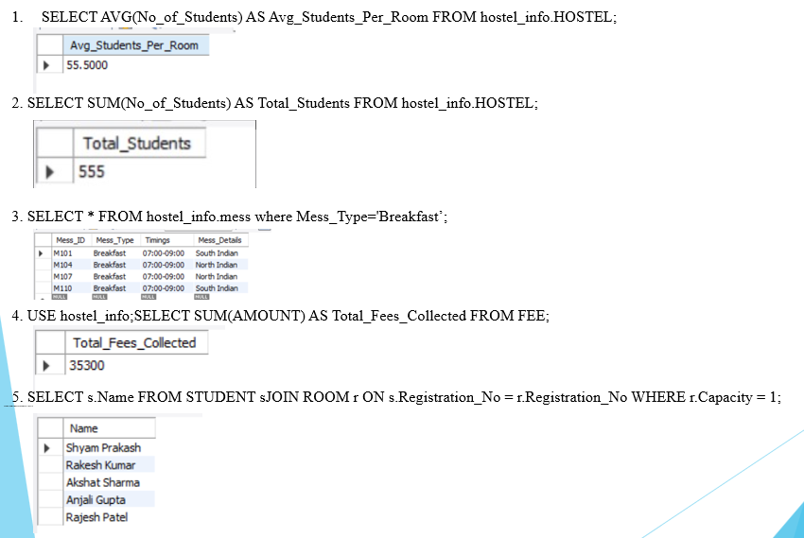**Lists of Queries:**

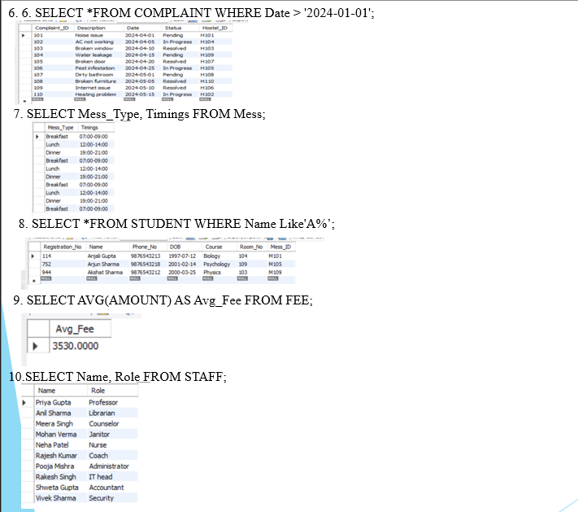

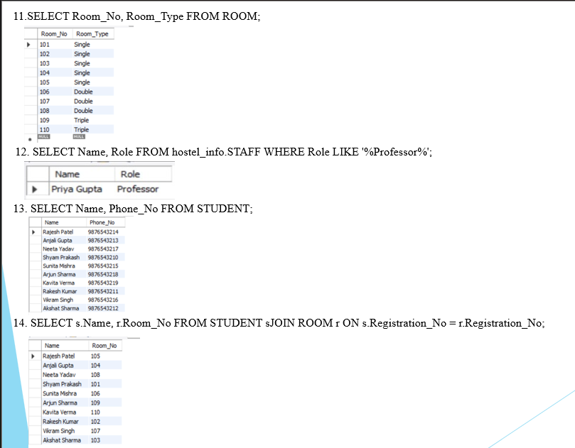

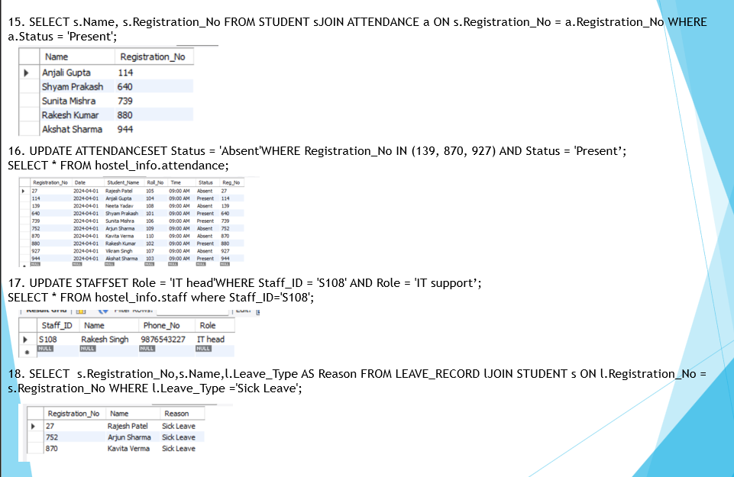

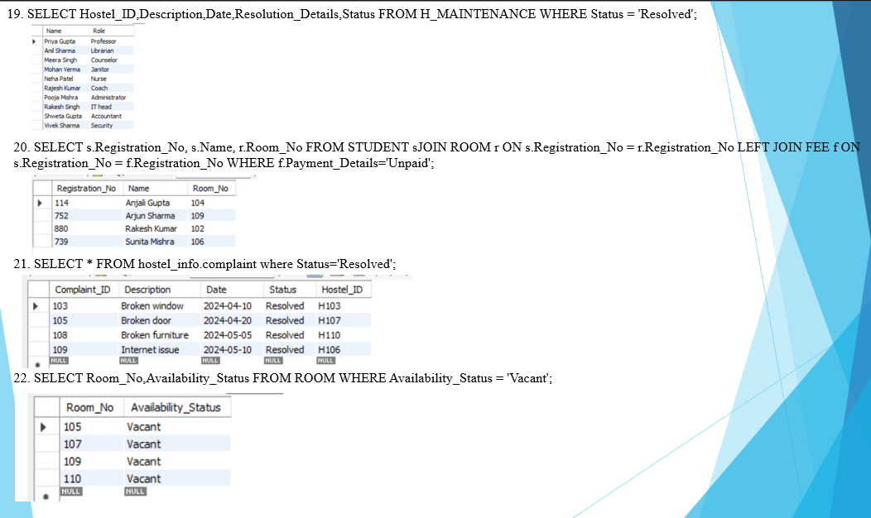

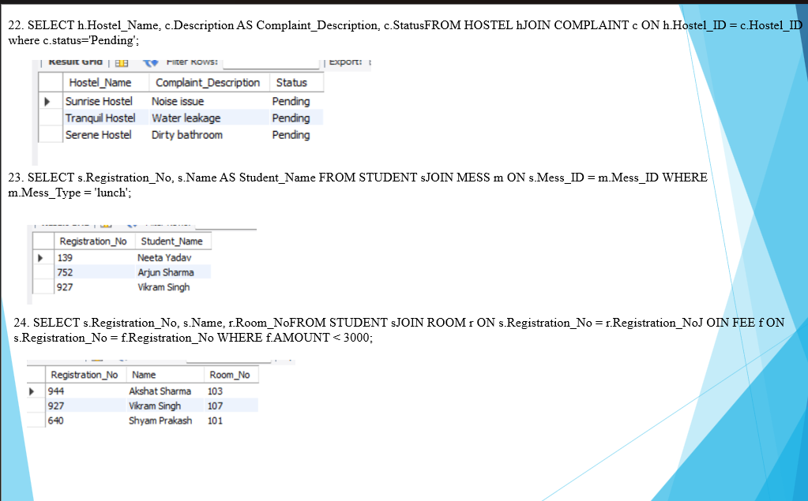

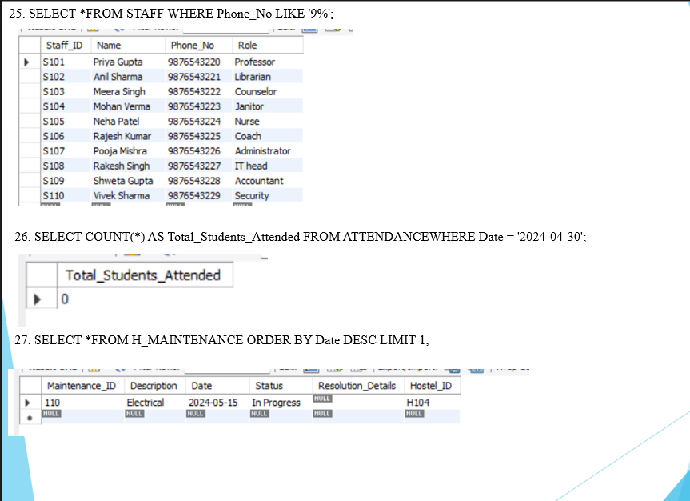

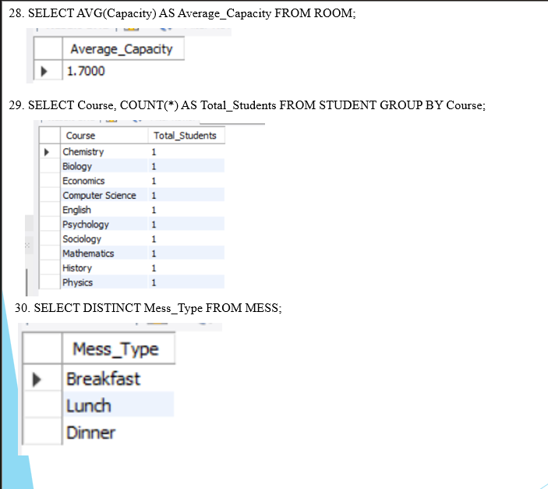

CONCLUSION

In conclusion, a hostel management system is an essential database system that helps hostel managers to manage and organize their daily operations efficiently. The system stores data on room allocation, students' personal details, meal plans, fee payments, and other critical information required for managing the hostel.

The hostel management system enables administrators to generate reports, monitor students' activities, and communicate with parents or guardians. Additionally, the system facilitates better coordination between staff members and ensures that students' needs are met promptly.

Implementing a hostel management system in a database provides a reliable and secure way of managing hostel operations. The database ensures that the data is accurate, consistent, and available to authorized personnel at any time.

Overall, a hostel management system in a database is a vital tool for efficient and effective hostel management.